Lesson 8: Race Condition Security Analysis
Logic Vulnerability — DVSA Order-Processing Workflow

Structured Analysis Summary
Table 1: Structured analysis summary — Table A
Vulnerability | Intended Rule(s) | Artifacts Used to Infer Rule | Normal Behavior Evidence | Exploit Behavior Evidence
Race Condition — Order Billing & Update | Once billing begins, no other operation should modify the order. Billing must read and charge the exact quantity the customer finalises. | DynamoDB order record, order_billing.py source, order_update.py source, API request/response logs, orderStatus field transitions | Normal checkout: billing reads qty=1, charges for qty=1, order finalised at qty=1 with correct totalAmount | Concurrent request: billing reads qty=1 and begins charging; update overwrites qty=5 before billing writes result; order finalised at qty=5 charged at qty=1 price

Table 2: Structured analysis summary — Table B
Vulnerability | Why This Is a Deviation | Deviation Class | Fix Applied (Where) | Post-Fix Verification | Optional Latency Before / After Logging
Race Condition — Order Billing & Update | The exploit violates the atomicity rule: billing should exclusively own an order from the moment it starts. Instead, update could freely overwrite the item list mid-billing, making the final charge inconsistent with the finalised order. | Misuse — concurrent legitimate API calls abused to produce an unintended financial outcome | order_billing.py: replaced get_item with conditional update_item (status 100 → 105). order_update.py: added ConditionExpression guarding on status = 100. | Re-ran identical race script post-deploy. Update rejected with "order is not in updatable state". Final order: status=120, qty=1, correct totalAmount. | N/A

1. Overview
A race condition in the DVSA order-processing API allowed a user to obtain more items than they paid for. By firing a billing request and a cart-update request simultaneously, the cart quantity could be changed after pricing was calculated but before the order was finalised.
This is a business logic flaw. The code behaved exactly as written — the design simply never prevented two operations from acting on the same order at the same time.

2. The Vulnerability

How It Worked
The ORDER-BILLING Lambda followed a read-then-write pattern with no lock:
- Read the order from DynamoDB (qty=1, price calculated for 1 item)
- Call the pricing service
- Charge the card
- Write the total and confirmed status back to DynamoDB

Between steps 1 and 4, the ORDER-UPDATE Lambda could freely write a new item quantity to the same record. Billing would finish and finalise an order that now contained 5 items — but the charge had been calculated on 1.

Attack Steps
- Create an order with qty=1 and add shipping details
- Fire a billing request and an update request (qty=5) simultaneously using & in bash
- If update wins the race: cart becomes qty=5 after billing has already priced qty=1
- Final order: 5 items received, $0 or qty=1 price charged

3. Exploit Demonstration
Order setup and concurrent requests fired. Billing crashes mid-execution as update mutates the record it is reading
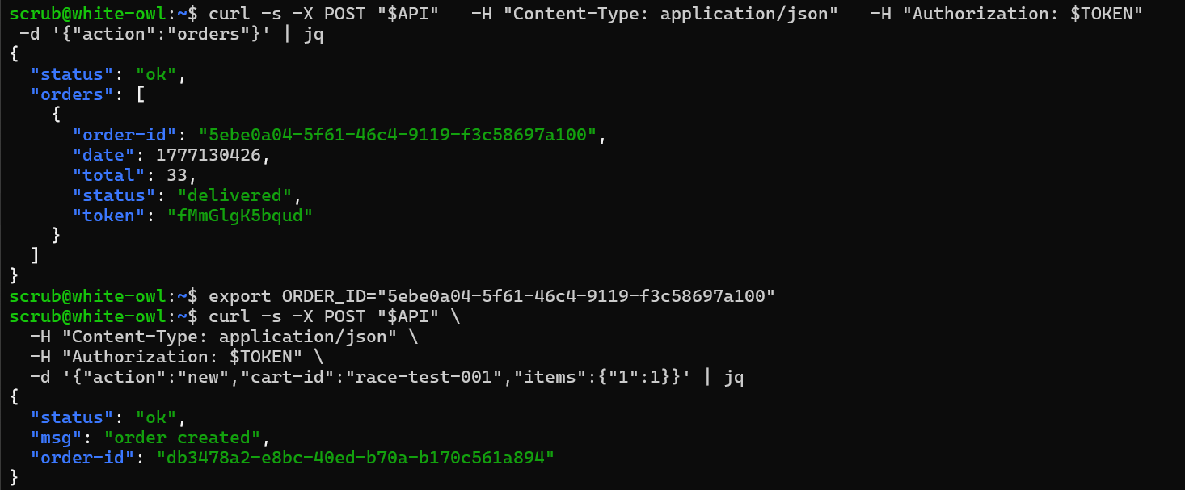
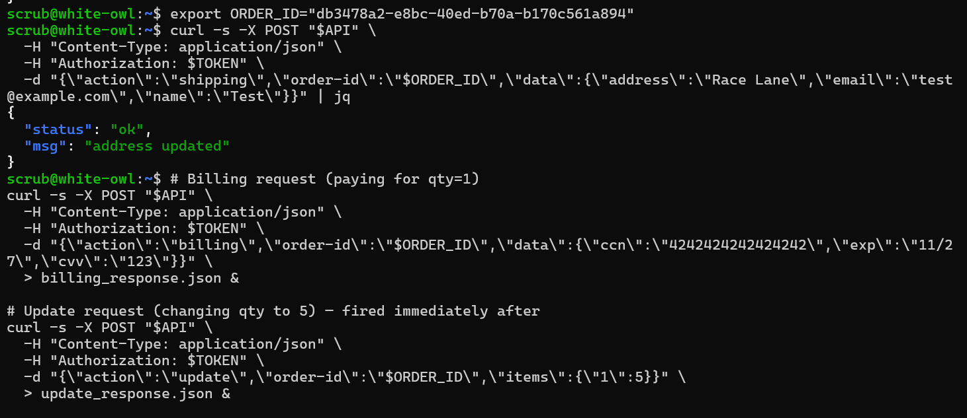

.

Results: billing KeyError, update succeeds. Final state shows qty=5 at totalAmount=0.

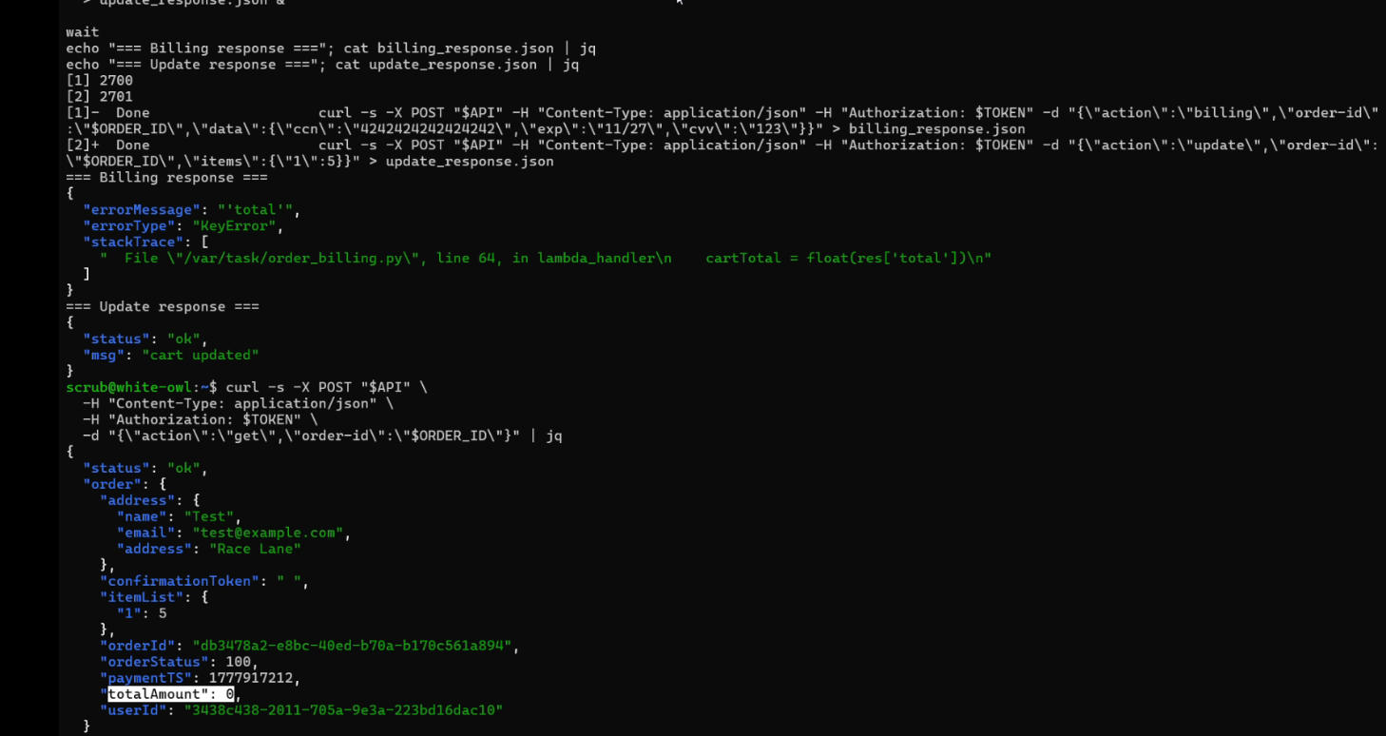

4. The Fix

Approach: Atomic Status Lock
The fix uses a DynamoDB conditional expression — a compare-and-swap — so that billing atomically reads the order and sets its status to 105 (in-progress) in a single operation. If the status is not 100 (open) at that exact moment, DynamoDB rejects the write entirely.
The update Lambda receives the same guard: it only writes if the status is still 100. The instant billing sets 105, any concurrent update is rejected. There is no gap between the check and the lock.

Changes Made
- ORDER-BILLING: replaced get_item with a conditional update_item that locks status to 105 and returns the record snapshot atomically
- ORDER-BILLING: used ReturnValues=ALL_NEW so the locked snapshot is the item variable — fixes the NameError crash
- ORDER-BILLING: added safety check for missing total key — fixes the KeyError crash
- ORDER-BILLING: added status reset to 110 on failure paths so orders cannot get permanently stuck at 105
- ORDER-UPDATE: wrapped update_item in the same conditional guard — rejects with "order is not in updatable state" once billing has started

Patched code — billing atomic lock (top), update conditional guard (bottom).
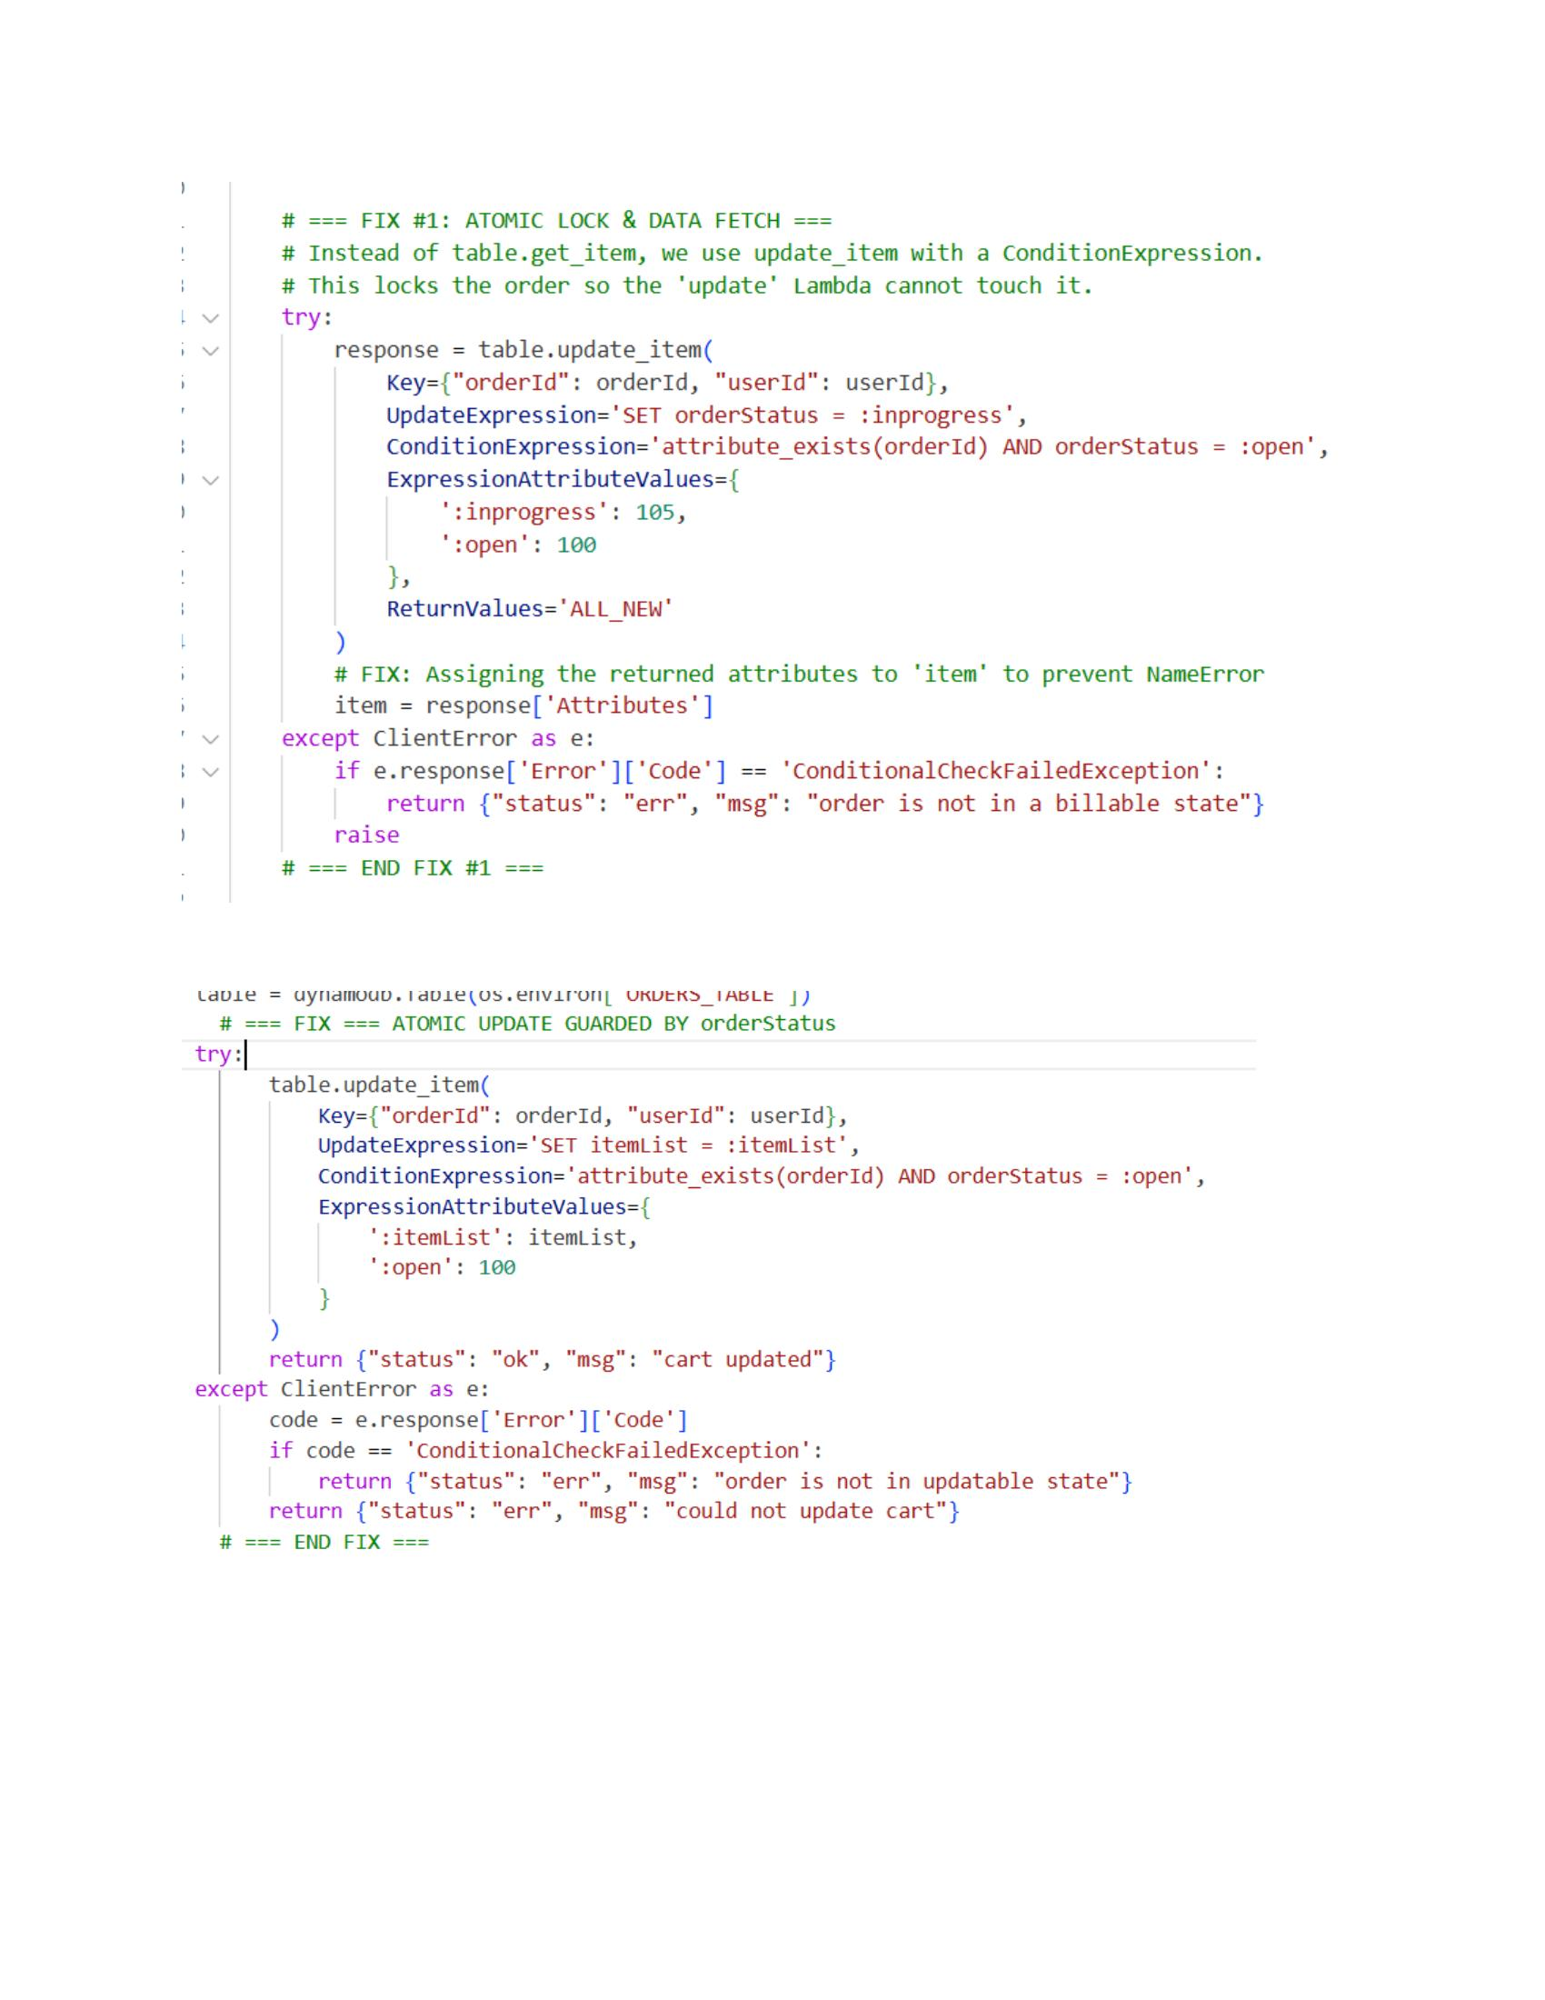

5. Verification
The same concurrent race script was re-run after deploying both patched Lambdas. The outcome was deterministic on every run regardless of which request arrived first.
- Billing: locked the order, processed payment correctly
- Update: rejected — "order is not in updatable state"
- Final orderStatus: 120 (Paid) — clean transition, no stuck orders
- Final totalAmount: correct value for qty=1
- Final itemList: {1:1} — quantity unchanged from what was charged

Verification output — update correctly rejected, order finalised at the right quantity and amount.
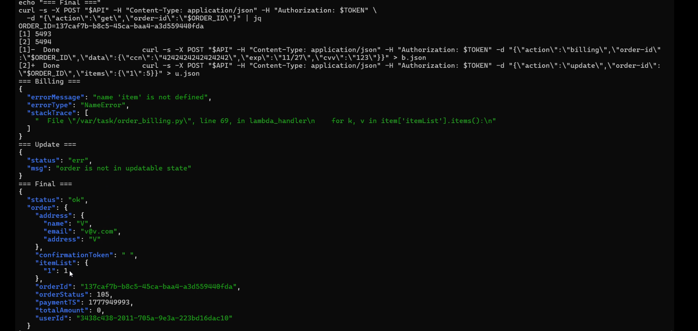

6. Key Takeaway
Distributed, stateless architectures must treat shared mutable state the same way multi-threaded code does — every read-modify-write cycle needs to be atomic, or protected by something that is. A DynamoDB conditional expression costs nothing extra and eliminates the entire class of TOCTOU vulnerability on any record it guards.

DVSA Lesson 8 | Race Condition | Identified · Exploited · Fixed · Verified

